🔹 Assignment 1: Permanent Table
A Permanent Table stores data permanently and supports both Time Travel and Fail-safe recovery in Snowflake.
Fail_safe recovery:- Fail-safe recovery in Snowflake is a 7-day, Snowflake-managed recovery period used only for disaster recovery after Time Travel expires.
Goal: Test persistence, Time Travel & recovery
Tasks:
- Create a permanent table EMP_PERM
create or replace table emp_perm(
emp_id int,
emp_name varchar(200),
dept varchar(200),
salary number(10,2),
join_date date
);
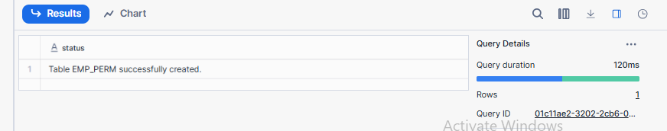
- Insert minimum 5 records
INSERT INTO emp_perm values
(1, 'Raj', 'IT', 25000, '2025-09-23'),
(2, 'Shilp', 'Azure', 30000, '2025-12-12'),
(3, 'Raji', 'Informatica', 35000, '2024-05-24'),
(4, 'Sudha', 'Salesforce', 45000, '2023-06-05'),
(5, 'Amara', 'HR', 35000, '2024-07-03');

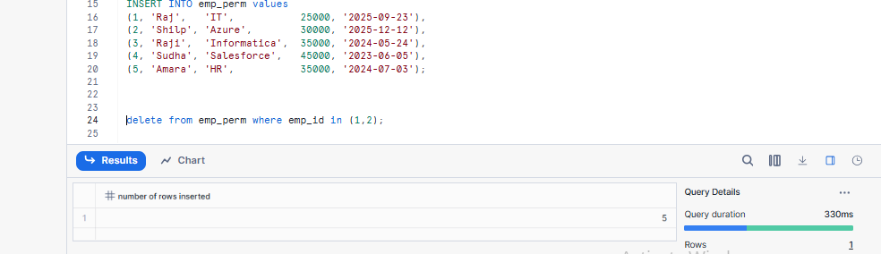
- Logout and login again
- Verify data persists
Select * from emp_perm;
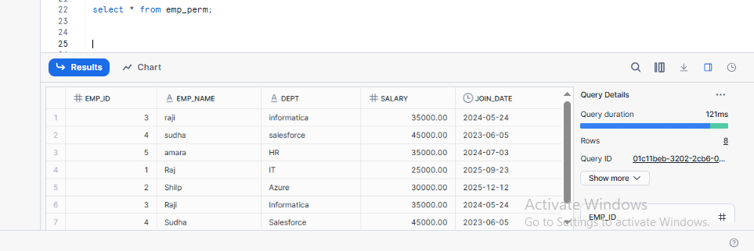
- Delete 2 records
delete from emp_perm where emp_id in (1,2);
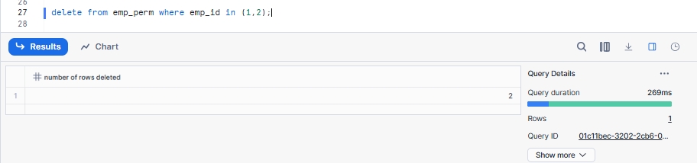
- Query deleted data using Time Travel
Time Travel:-Time Travel in Snowflake means going back in time to see or recover old data.
OFFSET:- OFFSET means the amount of time you go back from now, usually measured in seconds.
SELECT *
FROM emp_perm
AT (OFFSET => -60);

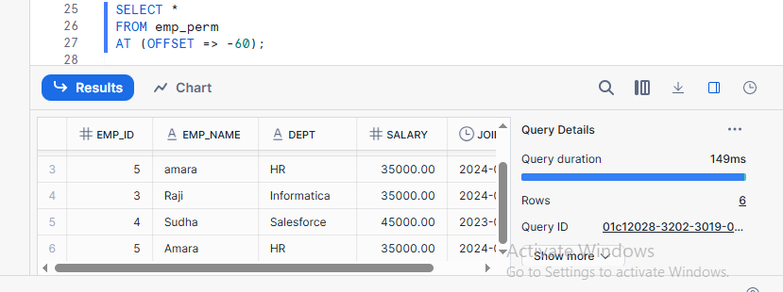
- Restore deleted data
INSERT INTO emp_perm
SELECT *
FROM emp_perm
AT (OFFSET => -60)
WHERE emp_id = 1;

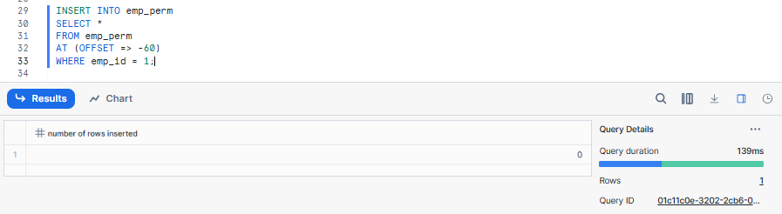
- Drop the table
DROP TABLE emp_perm;

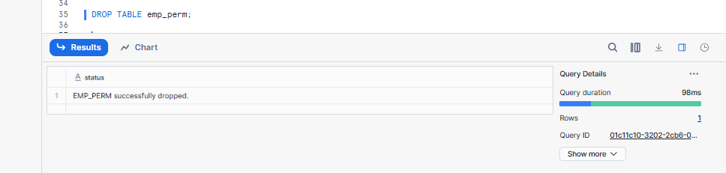
- Recover using UNDROP TABLE

UNDROP TABLE restores a table that was dropped accidentally, as long as it is still within the Time Travel retention period.

UNDROP TABLE emp_perm;
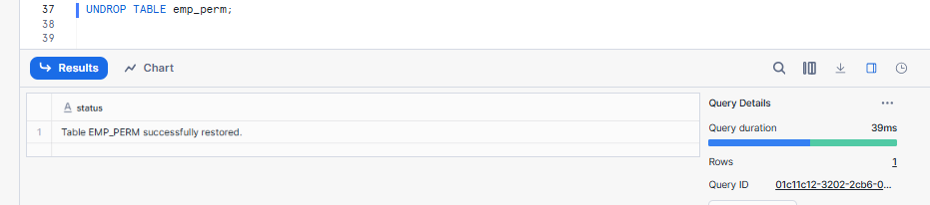
Learning Outcome:
✔ Data persists across sessions
✔ Supports Time Travel & Fail-safe

🔹 Assignment 2: Temporary Table
A temporary table in Snowflake exists only during the session and is automatically dropped when the session ends, with no recovery options.
Goal: Test session-based background cleanup
Tasks:
- Create temporary table EMP_TEMP
create or replace temporary table emp_temp(
emp_id int,
emp_name varchar(200),
dept varchar(200),
salary number(10,2),
join_date date
);
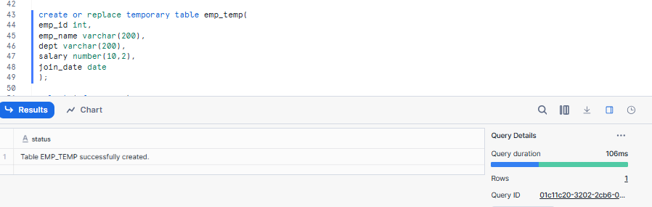
- Insert records
INSERT INTO EMP_TEMP values
(1, 'Raj', 'IT', 25000, '2024-01-10'),
(2, 'Anita', 'HR', 30000, '2023-03-15'),
(3, 'Kiran', 'Finance', 45000, '2022-07-01'),
(4, 'Meena', 'Sales', 28000, '2024-02-20'),
(5, 'Suresh', 'IT', 52000, '2021-11-05'),
(6, 'Priya', 'Marketing', 35000, '2023-09-18'),
(7, 'Rahul', 'Azure', 40000, '2022-12-12'),
(8, 'Divya', 'Informatica', 38000, '2024-05-25'),
(9, 'Amit', 'Salesforce', 47000, '2021-06-30'),
(10, 'Neha', 'HR', 29000, '2023-08-08');
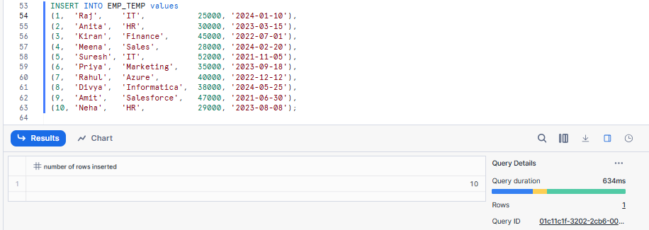
- Query data successfully
select * from emp_temp;
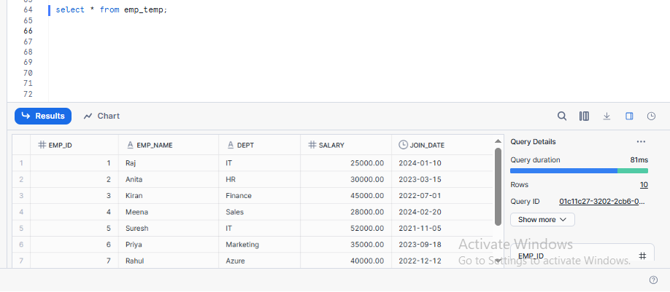
- End the session

- Reconnect and query the table

use database training_db;
use schema public;
use warehouse compute_wh;
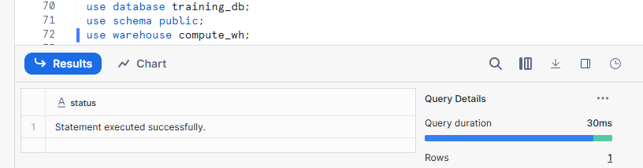
Learning Outcome:
✔ Table automatically removed after session ends
✔ No Time Travel or Fail-safe

🔹 Assignment 3: Transient Table
A transient table in Snowflake stores short-term data without Time Travel or Fail-safe support, making it cheaper but unrecoverable after drop.
Goal: Test limited retention behavior
Tasks:
- Create transient table EMP_TRANS
create or replace transient table emp_trans(
emp_id int,
emp_name varchar(200),
dept varchar(200),
salary number(10,2),
join_date date
);
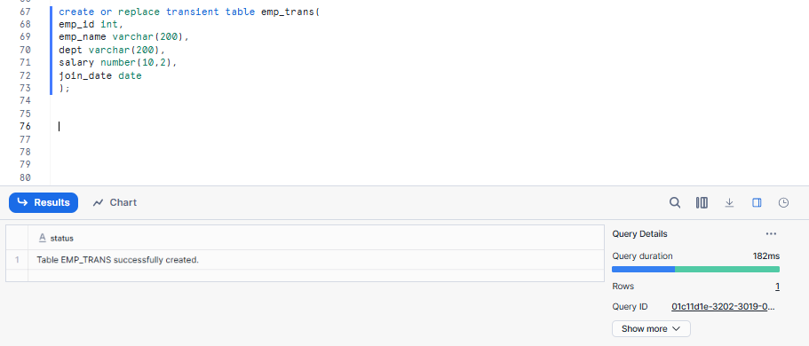
- Insert records
insert into emp_trans values
(1, 'Ravi Kumar', 'HR', 45000.00, '2022-01-15'),
(2, 'Anita Sharma', 'IT', 65000.00, '2021-07-10'),
(3, 'Suresh Reddy', 'Finance', 55000.00, '2020-03-25'),
(4, 'Priya Singh', 'IT', 70000.00, '2023-05-01'),
(5, 'Kiran Patel', 'Marketing', 48000.00, '2022-11-18'),
(6, 'Meena Rao', 'HR', 52000.00, '2021-09-30');

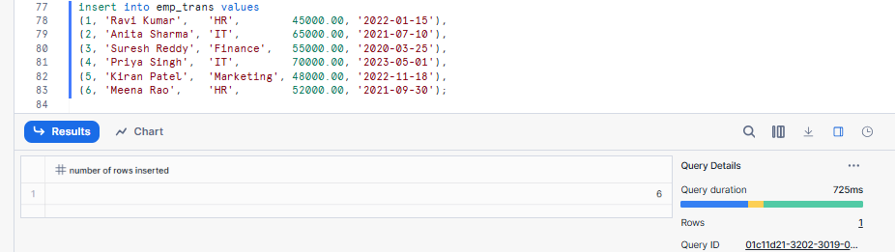
- Delete records
Delete from emp_trans
where emp_id = 3;
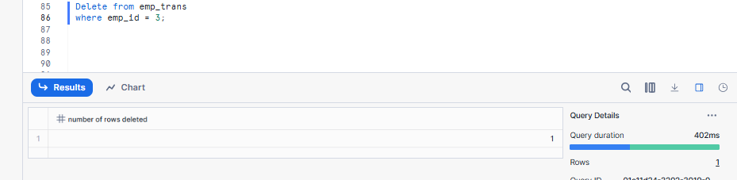
- Query data using Time Travel (within retention)
SELECT *
FROM EMP_TRANS
AT (OFFSET => -60);
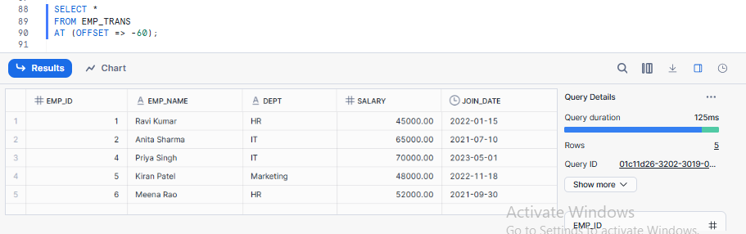
- Drop the table (Removing the structure and data)
drop table emp_trans;
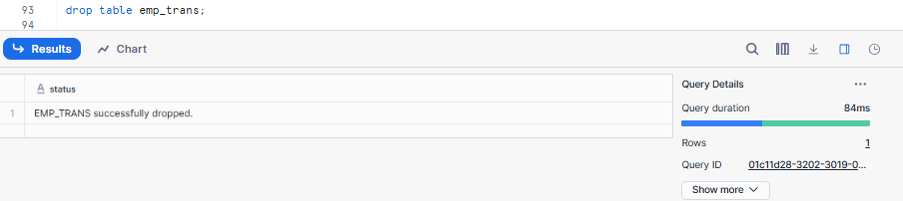
- Attempt recovery after retention period

Learning Outcome:
✔ Limited Time Travel
✔ No Fail-safe
✔ Faster background purge

🔹 Assignment 4: CTAS (Create Table As Select)
CTAS creates a new table and loads it with data from a SELECT query in a single step
Goal: Test background data transformation
Tasks:
- Create table EMP_HIGH_SALARY using CTAS
create or replace table emp_high_salary as
select *
from emp_perm
where salary > 45000;

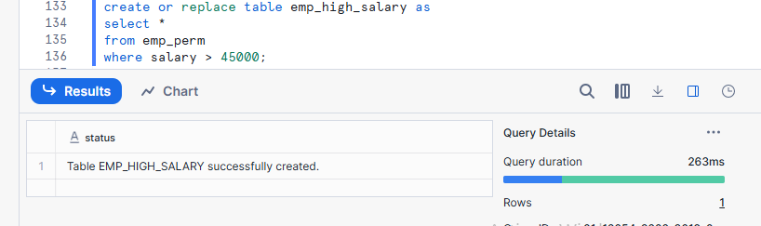
- Filter salary > 35,000
SELECT *
FROM EMP_PERM
WHERE SALARY > 35000;
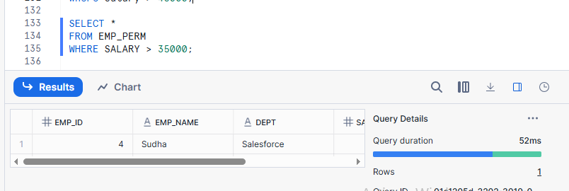
- Add calculated column SALARY_GRADE
alter table emp_perm
add column salary_grade varchar(10);

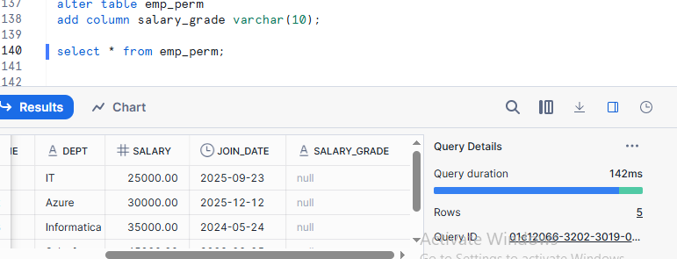
- Drop source table
Drop table emp_perm;
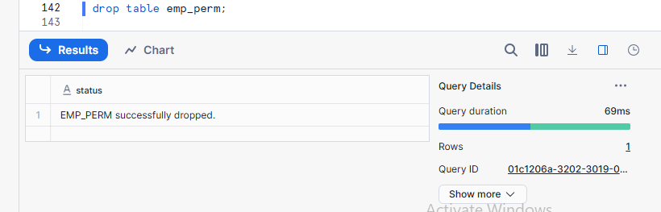
- Verify CTAS table still exists
Learning Outcome:
✔ Independent table creation
✔ Background transformation execution

🔹 Assignment 5: Table Cloning
A clone is a zero-copy copy of an object that initially shares the same data storage as the source.

Goal: Test zero-copy cloning
Tasks:
- Clone EMP_PERM as EMP_CLONE
CREATE TABLE EMP_CLONE
CLONE EMP_PERM;

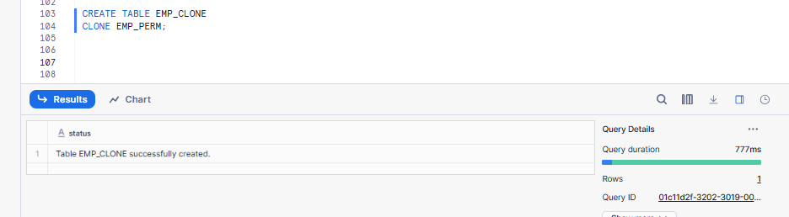
- Update data in cloned table
UPDATE EMP_CLONE
SET SALARY = SALARY + 5000,
DEPT = 'IT'
WHERE EMP_ID = 3;
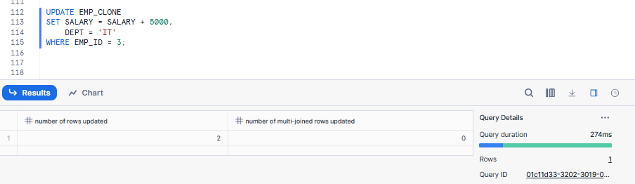
- Compare original vs clone
select * from emp_perm;

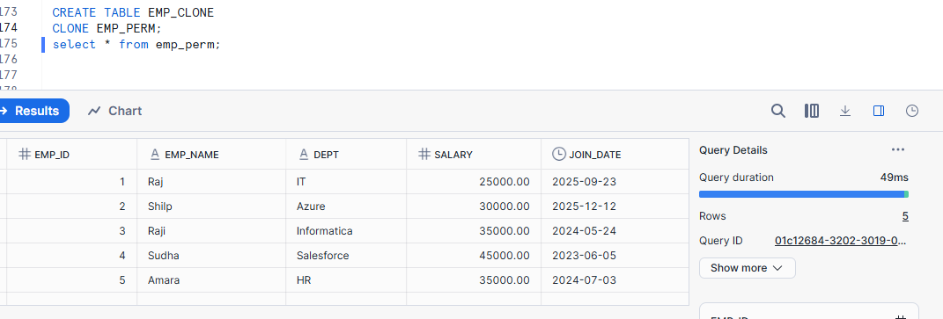
select * from emp_clone;
Updated emp_id = 3;

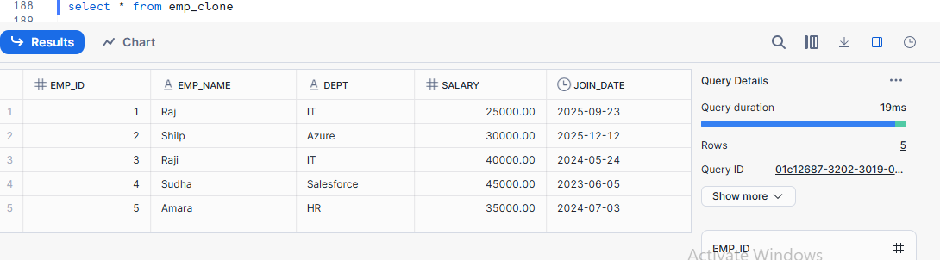
- Explain storage behavior
Learning Outcome:
✔ Zero-copy storage
✔ Independent data modification

🔹 Assignment 6: Time Travel Testing
Time Travel lets you view or restore old data from a table.
Goal: Test point-in-time recovery
Tasks:
- Perform DELETE on any table
Drop table emp_perm;
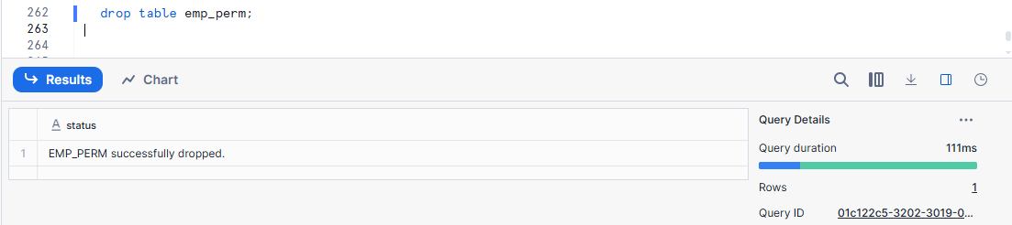
- Query using:
  - AT OFFSET
SELECT *
FROM emp_perm
AT (OFFSET => -300);
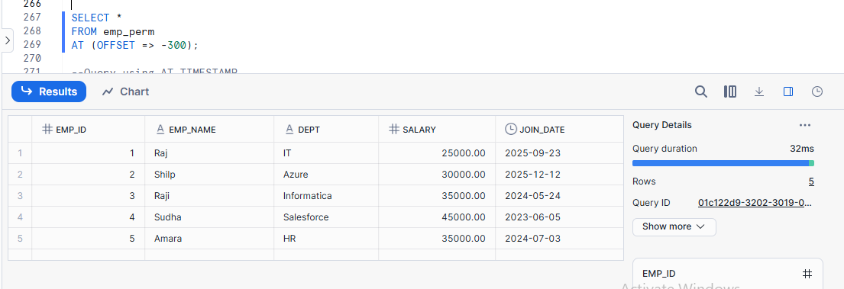

  - AT TIMESTAMP
SELECT *
FROM emp_perm
AT (TIMESTAMP => CURRENT_TIMESTAMP() - INTERVAL '2 MINUTE');
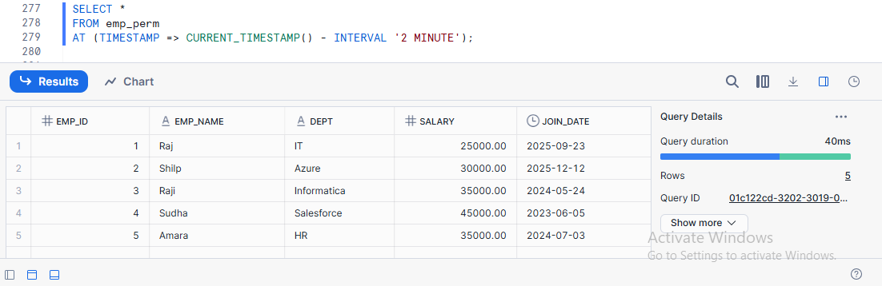
- Restore deleted data
Learning Outcome:
✔ Background versioning
✔ Point-in-time recovery

🔹 Assignment 7: Drop & Purge Behavior
Purege Behavior:- Purge behavior in Snowflake defines whether deleted or dropped data can be recovered or is permanently removed.
Goal: Compare cleanup rules
Tasks:
- Drop Permanent table and recover it
drop table emp_perm;
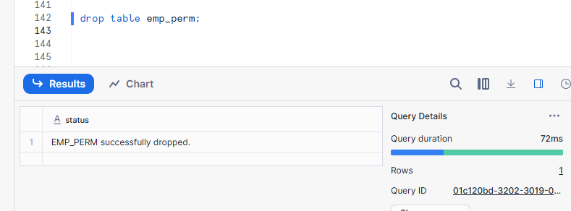
Undrop table emp_perm;
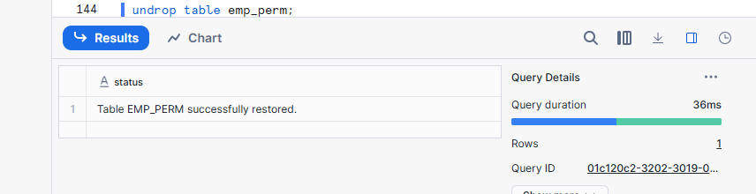
- Drop Transient table and attempt recovery
Drop table emp_trans;
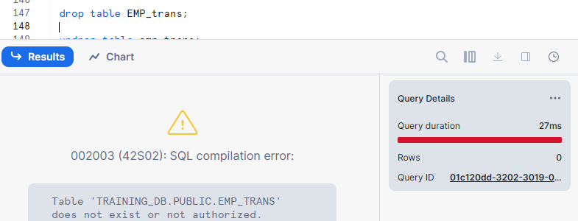
Undrop table emp_trans;

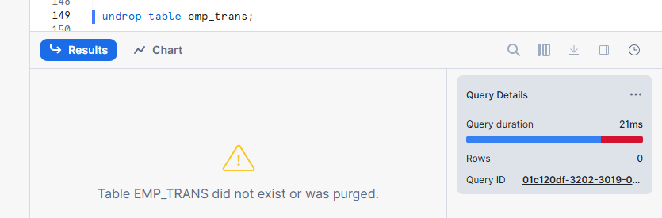
- Drop Temporary table and verify immediate removal
Drop table emp_temp;

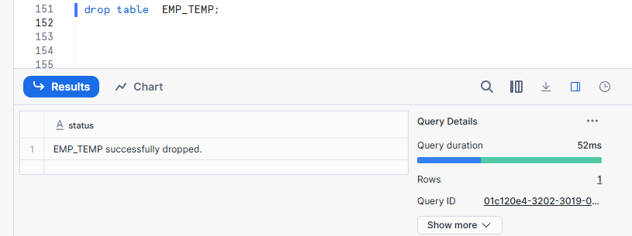

Undrop table emp_temp;
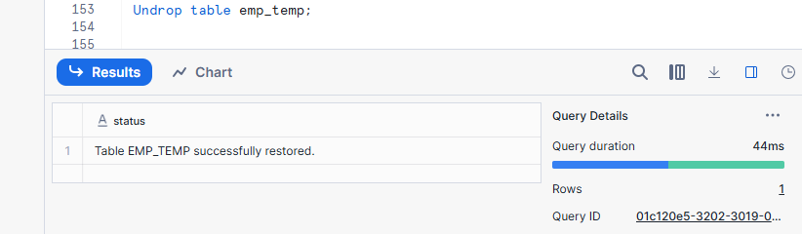
Learning Outcome:
✔ Different purge behavior per table type

🔹 Assignment 8: External Tables
External Table = Table that reads data directly from external cloud storage.
Goal: Query data stored outside Snowflake
Tasks:
- Create an external stage (S3 / ADLS / GCS)
- Create an external table on CSV or JSON data
- Query external table
- Add new file to external storage
- Refresh metadata and re-query
Questions to Answer:
- Does Snowflake store the data?
- Is Time Travel supported?
- What happens when source file is deleted?
Learning Outcome:
✔ Metadata-only tables
✔ No data storage inside Snowflake
✔ Manual metadata refresh

🔹 Assignment 9: Dynamic Tables
Dynamic Tables are tables that automatically refresh their data based on changes in source tables.
Goal: Test automated background refresh
Tasks:
- Create a source table SALES_RAW
create or replace table sales_raw(
sale_id int,
sale_date date,
product string,
region string,
amount number(10,2)
);
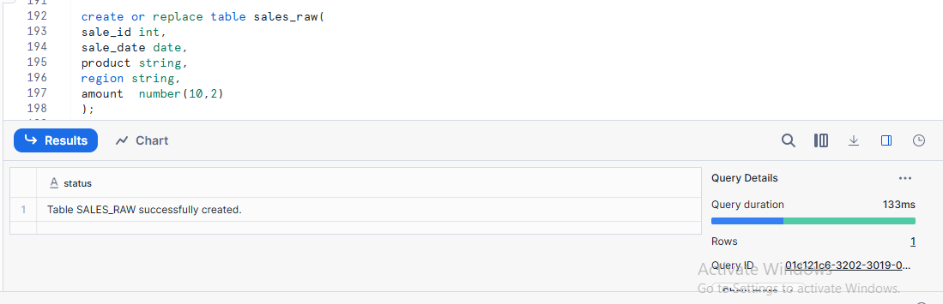
- Insert sample sales data
INSERT INTO SALES_RAW VALUES
(1, '2024-01-01', 'Laptop', 'East', 50000),
(2, '2024-01-02', 'Mobile', 'West', 30000),
(3, '2024-01-03', 'Tablet', 'North', 20000),
(4, '2024-01-04', 'Laptop', 'South', 45000),
(5, '2024-01-05', 'Mobile', 'East', 35000);
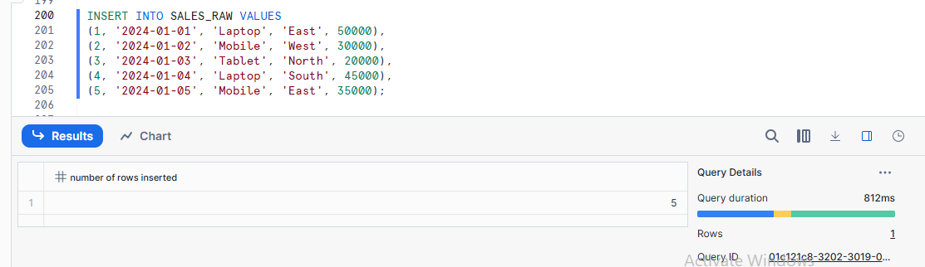

- Create a Dynamic Table SALES_AGG_DT
  - Aggregate total sales by region
CREATE OR REPLACE DYNAMIC TABLE sales_agg_dt
TARGET_LAG = '1 minute'
WAREHOUSE = compute_wh
AS
SELECT
region,
SUM(amount) AS total_sales
FROM sales_raw
GROUP BY region;

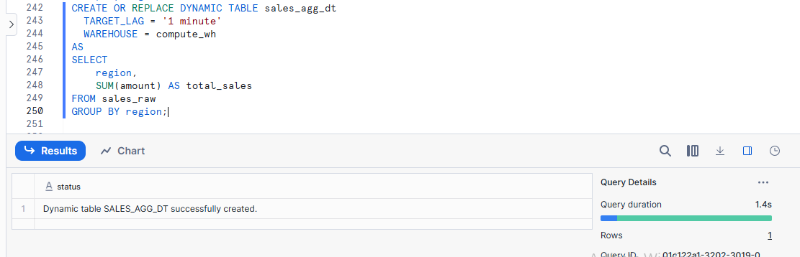
- Set refresh lag (e.g., 1 minute)
To set a refresh lag for a Dynamic Table, use the TARGET_LAG property.

- Insert new data into SALES_RAW
INSERT INTO sales_raw (region, amount)
VALUES
('North', 1200),
('South', 1800),
('East', 900);
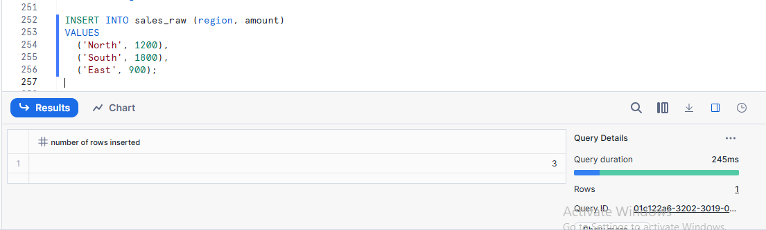
- Observe automatic refresh
SELECT * FROM saes_agg_dt;
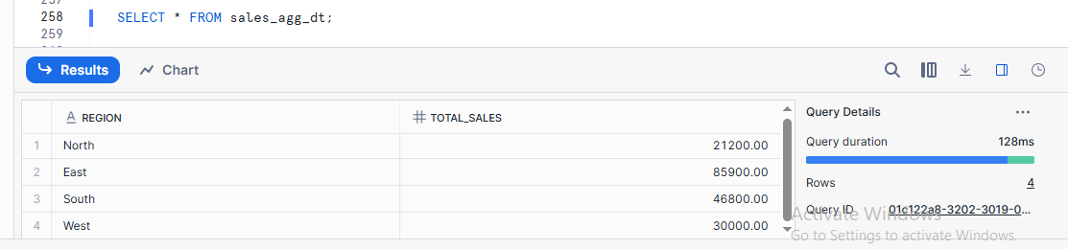
Questions to Answer:
- Is manual refresh required?
Manual refresh is not required for dynamic tables because Snowflake automatically refreshes them based on the target lag.
- How does refresh lag work?
Refresh lag controls how much delay is allowed between source data changes and dynamic table updates.
- Difference between Dynamic Table and Task + Table?
Learning Outcome:
✔ Automatic background refresh
✔ Declarative transformation logic

🔹 Assignment 10: Comparison & Analysis
Comparison & Analysis means comparing data or objects and studying the differences to make decisions.
Goal: Conceptual understanding
Tasks:
Create a comparison table for:
- Permanent vs Temporary vs Transient
- Internal vs External Tables
- Static Tables vs Dynamic Tables
Include:
- Storage
- Time Travel
- Fail-safe
- Refresh behavior
- Use cases

📦 Student Deliverables
- SQL scripts
- Output screenshots
- Answers to conceptual questions
- Final comparison table

⏱️ Estimated Time
🕒 2 – 2.5 Hours

✅ Evaluation Criteria
- Correct execution: 40%
- Understanding of background behavior: 40%
- Explanation & documentation: 20%

